Enabling multi-level response to the COVID-19 pandemic with eHealth platform solutions
The spread of SARS-CoV-2 - Coronavirus disease (COVID-19) around the world presents huge challenges to health care systems and disease outbreak management. Some countries can build on strong information and healthcare systems whereas others, particularly resource poor countries are highly vulnerable.
SATMED is a multi-level software-as-a-service eHealth platform owned by the Government of Luxemburg aimed to help healthcare providers make better use of information technology and mobile health solutions specifically in remote and underdeveloped areas. It is in operation since 2014, has been tested in cooperation with several partner NGOs incl. CURE, Friendship, German Doctors, Archemed, and has been installed in hospitals, remote medical centers and hospital ships in multiple locations across Africa and Asia Pacific, after its initial roll out in Sierra Leone during the Ebola outbreak.
With health systems and public health authorities facing the new pandemic, the digital health solutions and eHealth platforms become key components in coping with the ongoing COVID-19 outbreak and indispensable tools to immediately increase the resilience of the health service delivery systems.
In the light of the COVID-19 outbreak, the Government of Luxembourg will make the access to the SATMED platform available free of charge for healthcare professionals’ community of selected health organisations to fight the pandemic. All e-health applications integrated within the platform are license free. The SATMED interface is easy and intuitive to use & all applications are accessible by a single sign on. With a software as a service (SaaS) licensing and delivery/distribution model the platform is immediately accessible from any device with an Internet connection and a web browser. Last but not least, cloud data storage capabilities are provided (hosted in Luxembourg), compliant with data protection regulations.
Multi-level response eHealth platform
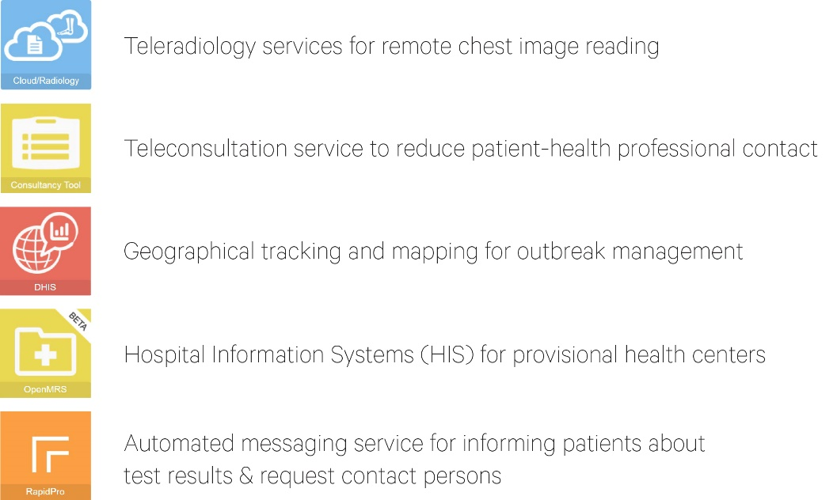

Where can SATMED help?
Teleconsultation service as public health measure
The protection of medical staff against infection is one of the most important measures in the fight against the pandemic. An important element in this respect is to reduce patient-health professional contacts. Telemedicine is an ideal solution. That is why many large hospitals have already invested strongly in teleconsultation solutions in recent weeks.
SATMED platform includes a teleconsultation application that can be easily adapted to the needs of different medical disciplines and the regional context. The consultancy function can be combined with any kind of videoconferencing.
Teleradiology services for remote chest image reading
COVID-19 leads to interstitial pneumonia causing severe respiratory distress. Imaging such as chest x-ray is therefore an important and reliable diagnostic tool, but also essential in differential diagnosis procedures.
SATMED integrates a very easy to use teleradiology function for remote reading of x-ray, CT, MRI or ultrasound images.
Automated messaging service for distribution of patients’ test results, updates and alerts
The ability of public health authorities to collect, qualify and distribute the data on the spread of the disease and deployment of data-driven mitigation and information strategies are key tools to counter the pandemic.
With the ongoing improvements in developments and availability of test devices, the time from sampling to result’s reporting can be reduced from 1-3 days to just a few hours and it is therefore important that test results are distributed as soon as known along with qualified information about rules of conduct such as quarantine requirements that may follow.
SATMED provides as part of its applications suite the RapidPro software solution - an automated mobile-based messaging system which allows i.e. to use multiple communication channels (ie SMS, voice, and social media) or sending messages in multiple languages to the local population.
Hospital Information Systems (HIS) for provisional health centers
All over the world, hotels, exhibition halls or other public venues are being converted into temporary health care centers. The Ebola crisis has demonstrated how crucial it is to connect the operations of such provisional health centers to hospital information systems (HIS) of national healthcare systems.
In order to allow quick implementation of a basic HIS at any location of the world, SATMED supports the integration of a local OpenMRS instance – that enables users to collect and manage electronic medical records for several different objectives.

Outbreak management with Geographical Tracking and Mapping
The regional monitoring and tracking of the spread of SARS-CoV-2 coronavirus is an important element for identifying disease hot spots, the management of resources and updating the population about the current status of the disease.
With DHIS2 tool integrated as part of SATMED platform, the system enables collection and presentation of epidemiological information with real-time visualisation in a dashboard. In combination with RapidPro automated SMS messaging system the local health authorities can set up and maintain targeted measures to surveil the spread of the disease and inform & alert the population in timely manner.

For more information and subscription request contact us here

